# 

# 

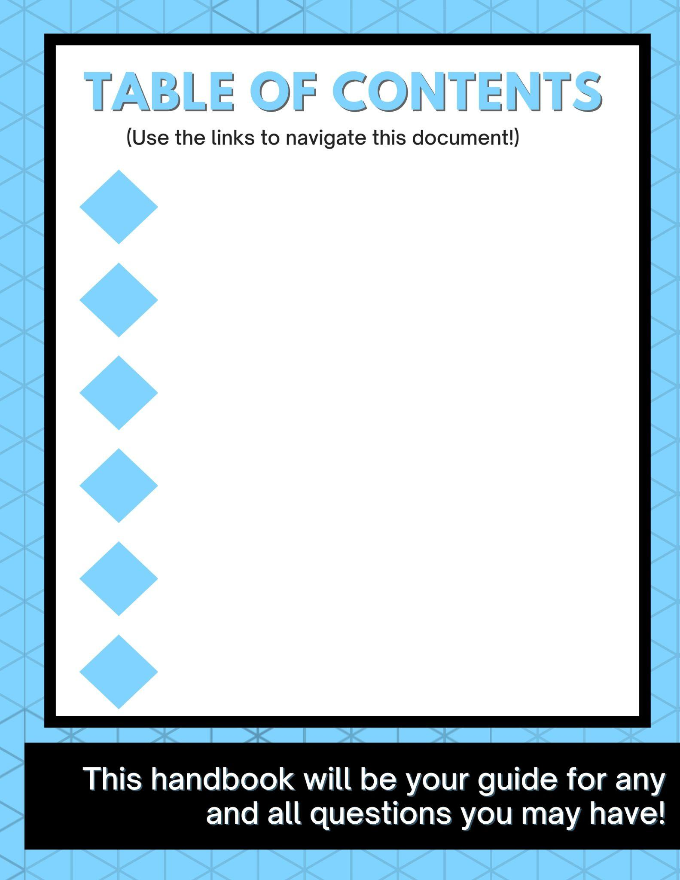

# 

Who We Are

About the Course

Course Logistics

Checklist of Onboarding Items

Course Structure

Course Technology

Course Calendar, Outline and Materials

More Course Information

Absence Policy & Certificate Information

Note-taking & Lecture Recordings

Copyright and Sharing Materials Policy

Student Safety and Privacy

Code of Conduct & Reporting a Violation

Data Privacy Policy

Community Norms: Engaged, Supportive, Inclusive

Student Resources

Office Hours

Live Help During Labs

Frequently Asked Questions

Help Form

Instructors and Guest Speakers

Lead Instructor: Adam Pearson

Guest Speaker: Dr. William Oliver

Guest Speaker: Dr. Krysta Svore

# Who We Are



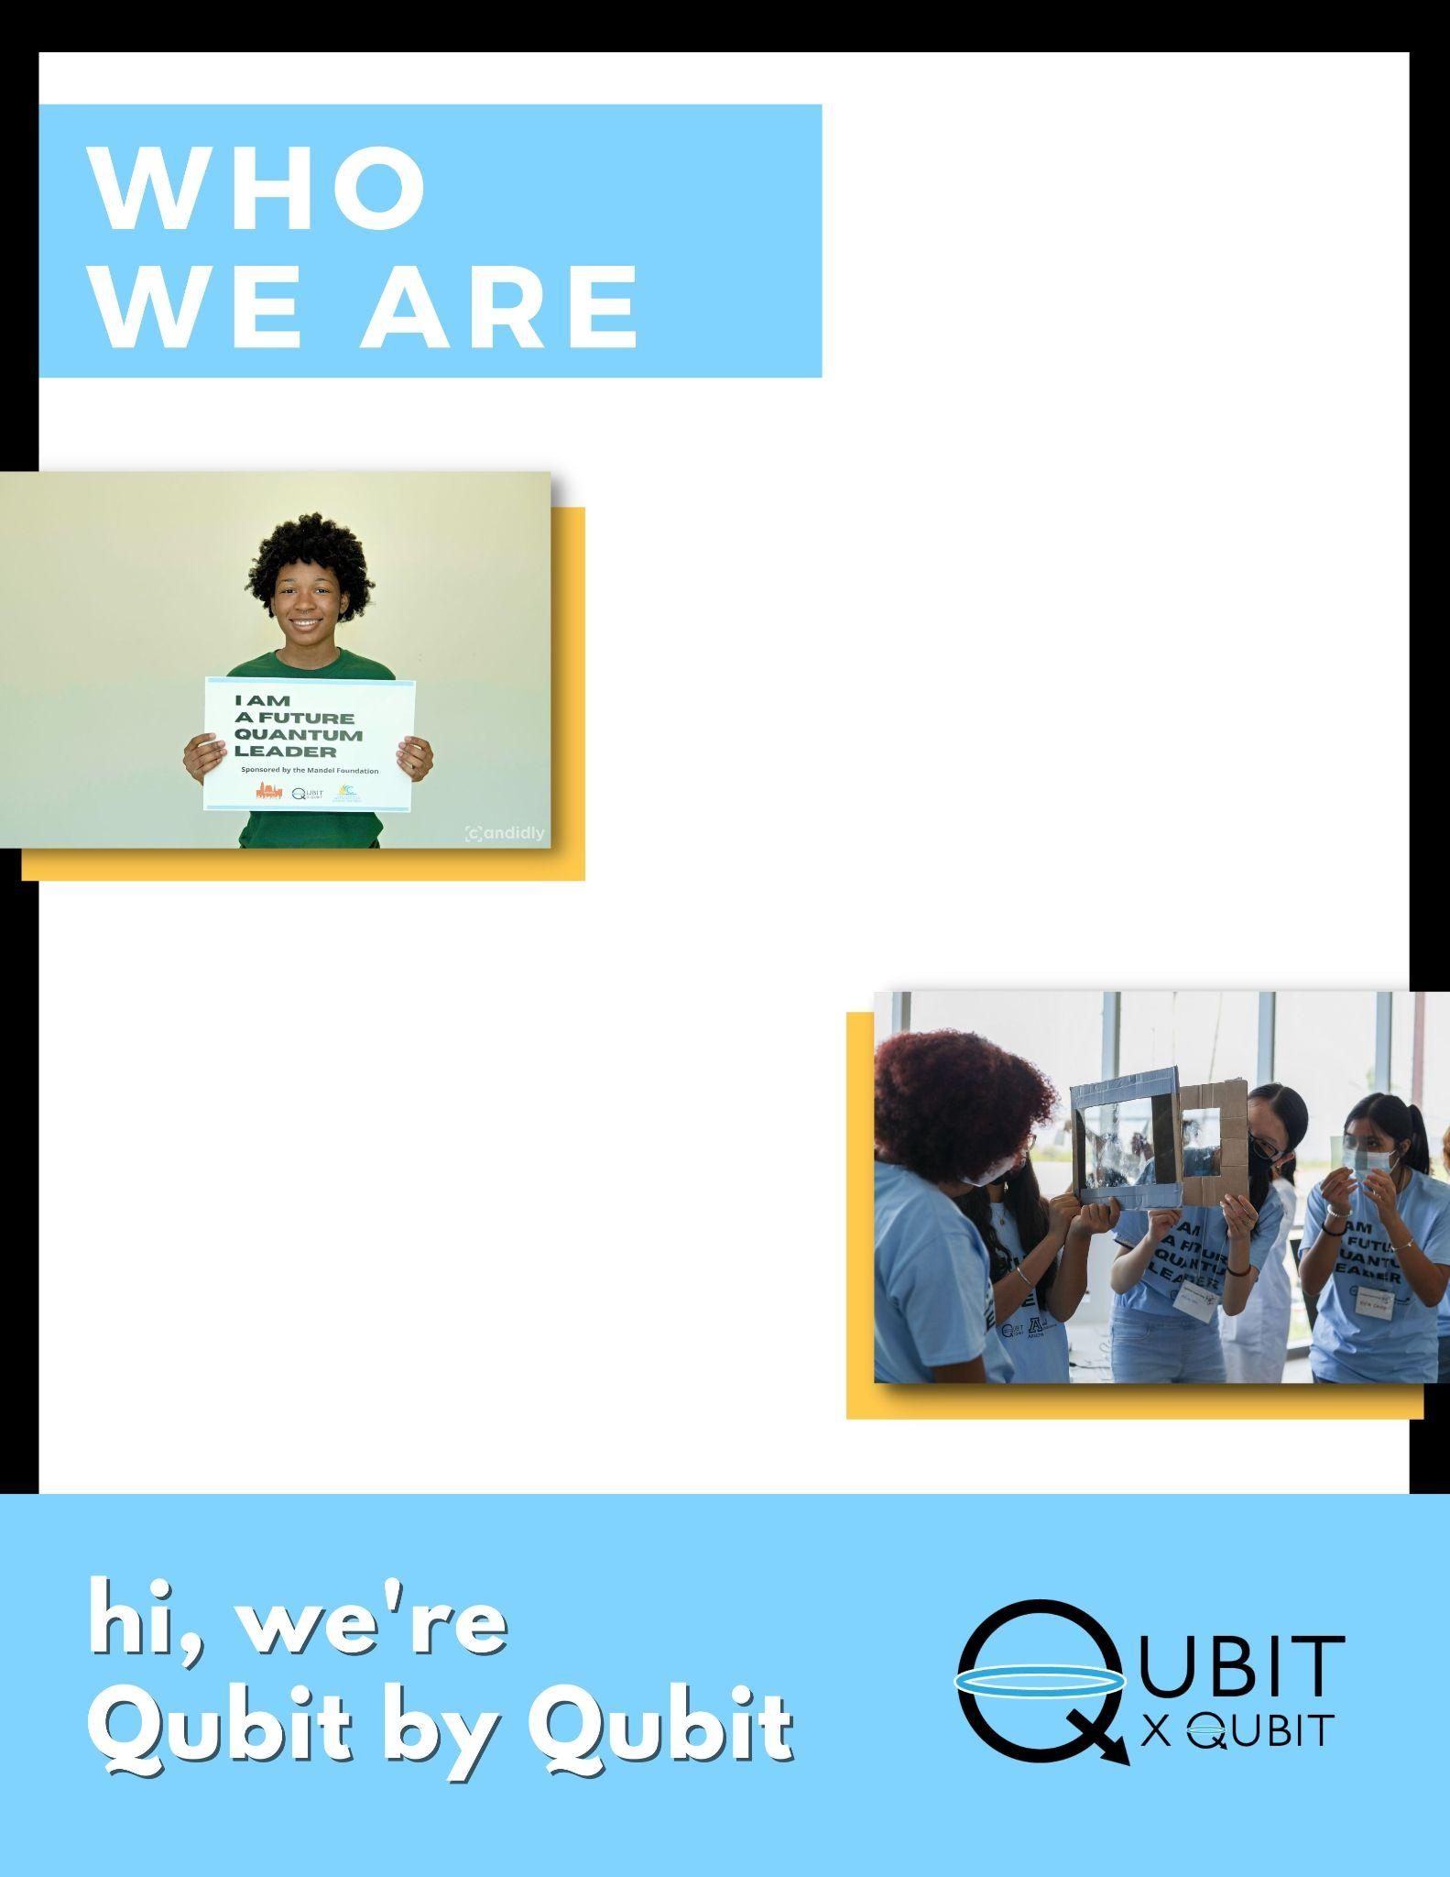

# 

# 

# 

# 

# 

# About the Course

### 

### 

### 

### Description

Qubit by Qubit’s *Quantum Winter School* with Microsoft Azure Quantum is a 4-day intensive introductory program for high school and undergraduate students to learn about the exciting interdisciplinary field of quantum computing.

Quantum is the next frontier of computing technology, and we want students to be at the forefront of this computing revolution. Over the next two weekends, you will learn the foundations of quantum computing, including quantum mechanics, quantum circuits, and quantum algorithms and protocols, all while gaining familiarity with Microsoft’s quantum computing language, Q#.

In lectures, labs, and at guest speaker events, you will also learn about various quantum applications, including in healthcare, finance, and cybersecurity. Further, you will hear from industry experts about their vision for the future of quantum.

**At Qubit by Qubit, our mission is to train the future diverse quantum workforce.** Our hope is that in taking this course, you will feel empowered and excited to continue learning about this technology– whether through additional programming, in university, or beyond.

**Prerequisite**: You do not need a background in quantum computing to take this course - you are just expected to have basic computer science knowledge (working knowledge of variables, function, loops).

# Course Logistics

## Checklist of Onboarding Items

***Please complete all of these before the start of the course. Don’t worry, these items***

***are all explained in detail below!***

* Read this Winter School handbook
* Register for the Zoom link [**HERE**](https://us06web.zoom.us/webinar/register/WN_gogdXI9FThqa8NuYci3xUg)
* Sign up for the course’s Azure Edu platform by following along with [**THIS**](https://docs.google.com/document/d/1aKmPquhZgZQrycJbLMvRSw2ztACBi6U3/edit)step-by-step guide
* (Optional) Sign up for QxQ’s Discord channel [here](https://discord.gg/aZazyxUdC8) and submit a [Help Form](https://airtable.com/shrqyql22cJFi74wk) ticket with your username to be onboarded
* **(Once you have onboarded to Azure Edu or registered for a Help Desk session)** Receive your lab assignment in a second email and register for its Zoom link
* Get excited!!

## Course Structure

Each day, the course will consist of two main components: a lecture and a lab. A few days of the course, there will also be optional programming.

* **Lecture:** All students will attend the lecture together. Lectures will be held on the same Zoom link the entire program.
* **Lab:** After lecture, students will split off into their separate lab sections. All students in the course have been assigned into one of the lab sections.
* **Optional programming:** In the program schedule below, you will see a few optional events.
  + **Office Hours:** A TA will be available on Sundays before lecture to answer any questions about the content you have learned so far.
  + **Guest Speakers:** Over the course of the program, we will be bringing in guest speakers in academia and industry to talk about their work, their paths, and their vision for the future of quantum. Though attendance is optional, it is highly encouraged!

## Course Technology

***For this course, you will use several different technology platforms. Each is outlined 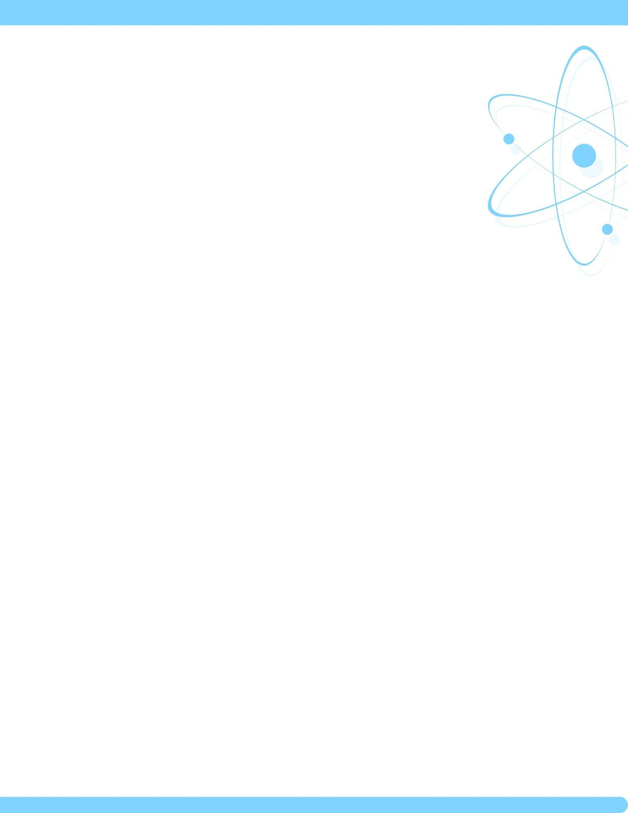below.***

### Zoom (video conferencing)

The video conferencing platform that we will use for this course is Zoom. We will use Zoom for all lectures, labs, and speaker events. **You will need to register for the lecture Zoom link and for your lab link before the start of the program.**

**Lecture registration link:** The lecture registration link is [**HERE**](https://us06web.zoom.us/webinar/register/WN_gogdXI9FThqa8NuYci3xUg). This will be the same link for every day of the program.

**Lab links:** You will receive your lab assignment and Zoom link within ~24 hours after you onboard to Azure Edu.

**Microsoft Azure Edu**

This is the platform we will be using to run code on real quantum computers. **Please follow the instructions in** [**this step-by-step guide**](https://docs.google.com/document/d/1aKmPquhZgZQrycJbLMvRSw2ztACBi6U3/edit) **very carefully to create an account and onboard before our first class. You will not receive the lab Zoom link until you onboard to Azure Edu.**

### Discord (optional)

**Website:** <https://discord.com/>

Discord is an informal communication platform for non-academic conversations between students. Students are *not* required to join the QxQ Discord server, but can join to get to know other students taking the course. Discord will not be used as the primary form of communication for any course-related material or announcements.

**Discord instructions:**

1. Create a Discord account if you do not already have one.
2. Join the QxQ server: <https://discord.gg/QpWq8TZCRc>
3. Submit the [Help Form](https://airtable.com/shrqyql22cJFi74wk) with your username and we’ll verify you as a student so that you can access the channels. We verify everyone joining our server to keep our Discord community safe for QxQ students. Please allow 2 business days to be verified.

## Course Calendar, Outline and Materials

***\*\*\*Each day of the course, the QxQ team will update the lab folders linked below to contain the materials you will use in your lab section that day.\*\*\****

| **Date** | **Event** | **Time** | **Description** | **Materials** |
| --- | --- | --- | --- | --- |
| **February 1st**  *Wednesday* | Azure Edu Platform Help Desk | 5 pm - 6 pm EST /  10 pm - 11 pm UTC | *Attendance is optional but recommended if you are having trouble onboarding to Azure Edu. Please register in advance.* | [Zoom Link](https://us06web.zoom.us/meeting/register/tZwtcuGgrTktHtR_Lsg5ydUXOF3gLXDcWNwp) |
| **February 2nd**  *Thursday* | Azure Edu Platform Help Desk | 7 am - 8 am EST /  12 pm - 1 pm UTC | *Attendance is optional but recommended if you are having trouble onboarding to Azure Edu. Please register in advance.* | [Zoom Link](https://us06web.zoom.us/meeting/register/tZ0rcOGrrD0pGdHJ-N7In9hJbTIkJRWS0Ea7) |
| **February 4th**  *Saturday* | Azure Edu Platform Help Desk | 11 am - 12 pm EST / 4 pm - 5 pm UTC | *Attendance is optional but recommended if you are having trouble onboarding to Azure Edu. Please register in advance.* | [Zoom Link](https://us06web.zoom.us/meeting/register/tZ0ucO-srz8qHtLmQ5R7Kzzy-TT2J1IDxcb8) |
| Lecture | 12 pm - 3 pm EST /  5 pm - 8 pm UTC | Introduction to Quantum Computing | [Zoom Link](https://us06web.zoom.us/webinar/register/WN_gogdXI9FThqa8NuYci3xUg) |
| Lab | 3 pm - 4 pm EST /  8 pm - 9 pm UTC | Introduction to Quantum Mechanics | *You will receive this link via email*  [Day 1 Folder](https://drive.google.com/drive/folders/1k_Bqk8s6Xn7R-U6XCkRFvGUdi94ARz7p?usp=sharing) |
| Azure Edu Platform Help Desk | 4 pm - 5 pm EST /  9 pm - 10 pm UTC | *Attendance is optional but recommended if you are having trouble onboarding to Azure Edu. Please register in advance.* | [Zoom Link](https://us06web.zoom.us/meeting/register/tZ0rcuyhpjMqEtb26cAJnG_U6P02nUEqLNmB) |
| **February 5th**  *Sunday* | Office Hours / Azure Edu Platform Help Desk | 10:30 am - 12 pm EST / 3:30 pm - 5 pm UTC | *Attendance is optional* | [Zoom Link](https://us06web.zoom.us/meeting/register/tZArdOChrT8oE9cCMqr7xi_HldZMemvTU0k1) |
| Lecture | 12 pm - 2 pm EST /  5 pm - 7 pm UTC | The Quantum Circuit Model | [Zoom Link](https://us06web.zoom.us/webinar/register/WN_gogdXI9FThqa8NuYci3xUg) |
| Lab | 2 pm - 4 pm EST /  7 pm - 9 pm UTC | Introduction to Coding Quantum Circuits with Q# | *You will receive this link via email*  [Day 2 Folder](https://drive.google.com/drive/folders/1WqR71jHALg4TxNaRMk6W-Jyo-nfft_yQ?usp=sharing) |
| TA Panel | 4 pm - 5 pm EST /  9 pm - 10 pm UTC | *Hear from your TAs about their paths to studying and working in quantum. Come prepared with questions!* ***Optional*** *but highly encouraged!* | *Same link as Lecture* |
| **February 9th** | Azure Edu Platform Help Desk | 8 am - 9 am EST  1 pm - 2 pm UTC | *Attendance is optional* | [Zoom Link](https://us06web.zoom.us/meeting/register/tZclce2vrTojG9RUT03J7vGemverVe9u5PSg) |
| Azure Edu Platform Help Desk | 6 pm - 7 pm EST  11 pm - 12 pm UTC | *Attendance is optional* | [Zoom Link](https://us06web.zoom.us/meeting/register/tZYlc-6sqj0oEtPSM9EO2wKWnClqB1yQdZO-) |
| **February 10th** | Azure Edu Platform Help Desk | 12 pm - 1 pm EST  5 pm - 6 pm UTC | *Attendance is optional* | [Zoom Link](https://us06web.zoom.us/meeting/register/tZMvcO-rrD8pGNegZzguRhkiwV_FTSNpapVI) |
| **February 11th**  *Saturday* | Azure Edu Platform Help Desk | 11 am - 12 pm EST | *Attendance is optional* | [Zoom Link](https://us06web.zoom.us/meeting/register/tZEucu-gqj0qGdDd3lbOcYB8j_LNGlwdQZui) |
| Lecture | 12 pm - 2 pm EST / 5 pm - 7 pm UTC | Quantum Algorithms and Protocols | [Zoom Link](https://us06web.zoom.us/webinar/register/WN_gogdXI9FThqa8NuYci3xUg) |
| Lab | 2 pm - 4 pm EST /  7 pm - 9 pm UTC | Quantum Key Distribution | *You will receive this link via email*  [Day 3 Folder](https://drive.google.com/drive/folders/1DApOtXA6Lh5Nw3AZ7lFoOmxl_k6aOfiw?usp=sharing) |
| Guest Speaker | 4 pm - 4:30 pm EST / 9 pm - 9:30 pm UTC | ***Dr. Will Oliver - optional*** *but highly encouraged!* | *Same link as lecture* |
| **February 12th**  *Sunday* | Office Hours | 10:30 am - 12 pm EST / 3:30 pm - 5 pm UTC | *Attendance is optional* | [Zoom Link](https://us06web.zoom.us/meeting/register/tZArdOChrT8oE9cCMqr7xi_HldZMemvTU0k1) |
| Lecture | 12 pm - 2 pm EST /  5 pm - 7 pm UTC | Quantum Computing Today | [Zoom Link](https://us06web.zoom.us/webinar/register/WN_gogdXI9FThqa8NuYci3xUg) |
| Lab | 2 pm - 4 pm EST /  7 pm - 9 pm UTC | Using Hybrid Algorithms to Solve Optimization Problems in Q# | *You will receive this link via email*  [Day 4 Folder](https://drive.google.com/drive/folders/1hRur8RcVLAbF0woIf07b3gAcbBnPYxBT?usp=sharing) |
| Guest Speaker | 4 pm - 4:30 pm EST / 9 pm - 9:30 pm UTC | ***Dr. Krysta Svore - optional*** *but highly encouraged!* | *Same link as lecture* |

# 

# More Course Information

## Absence Policy & Certificate Information

Students who attend lecture and lab all four days of the program will receive a certificate of completion jointly signed by Qubit by Qubit and Microsoft. Certificates will be sent to students via email after the program ends. 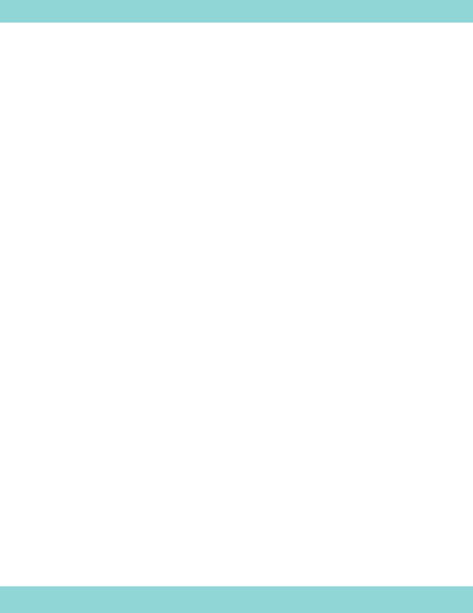Certificates will be shared electronically - Qubit by Qubit will not provide hard copies. **Live attendance for both lecture and lab is required.**

**To request an excused absence, you must fill out this** [**Help Form**](https://airtable.com/shrqyql22cJFi74wk) **at least two days prior to the portion of class you plan to miss**. If your absence request is granted, you will be required to watch a recording of the class(es) missed and complete a comprehension survey to demonstrate that you are caught up. After you submit the survey, the QxQ Team will review it to confirm you have watched the necessary material. In order to be eligible to receive the course certificate, your survey will need to be approved by the QxQ Team (don’t worry, so long as you actually watch the recording, you will do fine!). Without submitting this assessment for any class(es) missed, you will not be eligible for a certificate.

Students who miss more than the equivalent of one full day of class (4 hours of coursework) will not be eligible to receive a certificate. However, you may still otherwise participate in the course on the days you can attend, and will still receive the recordings so that you are able to catch up on the missed material.

## Note-taking & Lecture Recordings

Students are strongly encouraged to take notes during lecture and lab. Lecture and lab slides will not be shared. The course will be recorded, but recordings will only be available to students who have missed class, not for general review. Recordings will not be available once the course is over.

## Copyright and Sharing Materials Policy

All curriculum for this course, including but not limited to lecture slides, lab materials, and recordings are the copyrighted property of The Coding School. You are not allowed to circulate the materials to students outside of the course. Doing so will result in you removal from the course.

# 

# Student Safety and Privacy

We take student safety and privacy seriously. All instructional staff have undergone background checks and participated in sexual harassment training.

## Code of Conduct & Reporting a Violation

All students are required to agree to the Code of Conduct as a condition of enrolling in the program. **To read our comprehensive Code of Conduct, please click** [**here**](https://docs.google.com/document/u/2/d/1_2Onjpec138LYfuJ2iw58SKtpZsaWlCAUeT3iPkxdrQ/edit).

Qubit by Qubit takes Code of Conduct violations seriously. Depending on the severity of the concern, violations may result in immediate dismissal from the course.

**To report a Code of Conduct violation**, please fill out the form [here](https://airtable.com/shr2rjQAd1ZETLe08). For urgent matters, call our office or email us with the subject line ‘URGENT’ at [student@qubitbyqubit.org](mailto:student@qubitbyqubit.org).

## Data Privacy Policy

To view The Coding School’s data privacy policy, click [here](https://docs.google.com/document/d/1T2NmagkM5fa7xzRDvoHMQ3e1spSiD6Gd/edit?usp=sharing&ouid=111600568740434656892&rtpof=true&sd=true). To summarize, The Coding School does not sell, share, or distribute participants’ data to third parties.

## Community Norms: Engaged, Supportive, Inclusive

* TCS is committed to fostering a respectful, empowering learning environment for all students, instructors, staff, and visitors.
* We welcome students from all backgrounds, including those who are new to STEM. We are all on this learning journey together. Every student is on a level playing field, and we can all learn from one another. Students are not in competition with one another and should be supportive, not competitive.
* A core part of our mission is to make the future quantum workforce diverse and inclusive. We actively promote diversity in our courses and want all students to celebrate the different backgrounds and experiences of our students.
* Curiosity, effort, and engagement are valued over perfection. Our main ask is that you are engaged and do your best. Quantum computing is difficult, and we do not expect students to master it on the first - or even second or third - try.
* We ask students to be present, engaged, and supportive of one another.

# 

# Student Resources

***Feel like you’re falling behind in the course or have specific questions about***

***the material? These resources are for you!***

## Onboarding Help

If you are having trouble setting up your Azure Edu account, please attend one of

the below Help Desk sessions prior to the start of the course. As a reminder, you will not receive your lecture and lab Zoom links until after you onboard to Azure Edu.

Help Desk Times:

* Wednesday, February 1st at 5 pm EST / 10 pm UTC: [Zoom Link](https://us06web.zoom.us/meeting/register/tZwtcuGgrTktHtR_Lsg5ydUXOF3gLXDcWNwp)
* Thursday, February 2nd at 7 am EST / 12 pm UTC: [Zoom Link](https://us06web.zoom.us/meeting/register/tZ0rcOGrrD0pGdHJ-N7In9hJbTIkJRWS0Ea7)
* Saturday, February 4th at 10:30 am EST / 3:30 pm UTC: [Zoom Link](https://us06web.zoom.us/meeting/register/tZ0ucO-srz8qHtLmQ5R7Kzzy-TT2J1IDxcb8)
* Saturday, February 4th at 4 pm EST / 9 pm UTC: [Zoom Link](https://us06web.zoom.us/meeting/register/tZ0rcuyhpjMqEtb26cAJnG_U6P02nUEqLNmB)
* Sunday, February 5th at 10:30 am EST / 3:30 pm UTC - 5 pm UTC: [Zoom Link](https://us06web.zoom.us/meeting/register/tZArdOChrT8oE9cCMqr7xi_HldZMemvTU0k1)

## Office Hours

If you need additional help understanding concepts or with your code, you will have the opportunity to attend optional office hours with QxQ tutors. This will be an opportunity for you to have your questions answered individually or in a small group. The link to office hours is in the calendar on page 7.

Office Hour Times:

* Sunday, February 5th, 10:30 am - 12 pm EST / 3:30 pm - 5 pm UTC: [Zoom Link](https://us06web.zoom.us/meeting/register/tZArdOChrT8oE9cCMqr7xi_HldZMemvTU0k1)
* Sunday, February 12th, 11 am - 12 pm EST / 3:30 pm - 5 pm UTC: [Zoom Link](https://us06web.zoom.us/meeting/register/tZArdOChrT8oE9cCMqr7xi_HldZMemvTU0k1)

## Live Help During Labs

During Lab, there will be a QxQ team member stationed on the lecture Zoom link in case you have questions about course software (for example, if you are having trouble logging in to Azure Edu).

## Frequently Asked Questions

[2023 Quantum Winter School FAQ's](https://docs.google.com/document/d/1G0tW0f6xYJqrtYXubBt6p7mJmOXjTR4l3Gybg8Xv6CU/edit)

## Help Form

Still need assistance logging into Azure Edu or other course technologies? Need to request an absence? Submit the [Help Form](https://airtable.com/shrqyql22cJFi74wk) and our support staff will be happy to help within 1-2 business days. Note: the Help Form is *not* the place to ask content-related questions. Please go to Office Hours for those questions!

# Instructors and Guest Speakers

## Lead Instructor: Adam Pearson

Adam Pearson is currently the Academic Lead of The Coding School, designing curriculum and teaching courses in quantum computing, artificial intelligence and more. Adam completed his graduate studies in Physics at the University of Southern California, where he conducted research exploring specialized devices known as Quantum Annealers and their potential use for optimization problems with Dr. Daniel Lidar. Following his research, he decided to focus more on the communication of science, which has led him to developing curriculum for Quantum Computing and Machine Learning courses with The Coding School.

## Guest Speaker: Dr. William Oliver

Dr. William D. Oliver is jointly appointed Professor of Electrical Engineering and Computer Science, Professor of Physics, and Lincoln Laboratory Fellow at the Massachusetts Institute of Technology. He serves as the Director of the Center for Quantum Engineering and as Associate Director of the Research Laboratory of Electronics. He is a Principal Investigator in the Engineering Quantum Systems Group (MIT campus) and the Quantum Information and Integrated Nanosystems Group (MIT Lincoln Laboratory). He provides programmatic and technical leadership targeting the development of quantum and classical high-performance computing technologies. Dr. Oliver’s research interests include the materials growth, fabrication, design, and measurement of superconducting qubits, as well as the development of cryogenic packaging and control electronics involving cryogenic CMOS and single-flux quantum digital logic.

## Guest Speaker: Dr. Krysta Svore

Dr. Krysta Svore is passionate about empowering people and organizations around the world with quantum computing and realizing a scaled quantum machine. Her team designs and delivers Azure Quantum, the most diverse cloud platform for quantum research and discovery, and is developing a comprehensive software stack for scalable quantum computing including languages, compilers, and mappings to quantum hardware. Her team designs open software including Q# and QIR. Dr. Svore has published over 70 refereed articles and filed over 30 patents. She is a fellow of the American Association for the Advancement of Science. She won the 2010 Yahoo! Learning to Rank Challenge with a team of colleagues, received an ACM Best of 2013 Notable Article award, and was recognized as one of Business Insider Most Powerful Female Engineers of 2018. A Kavli fellow of the National Academy of Sciences, she also serves as an advisor to the National Quantum Initiative, the Advanced Scientific Computing Advisory Committee of the Department of Energy, and the ISAT Committee of DARPA, in addition to numerous other quantum centers and initiatives globally.